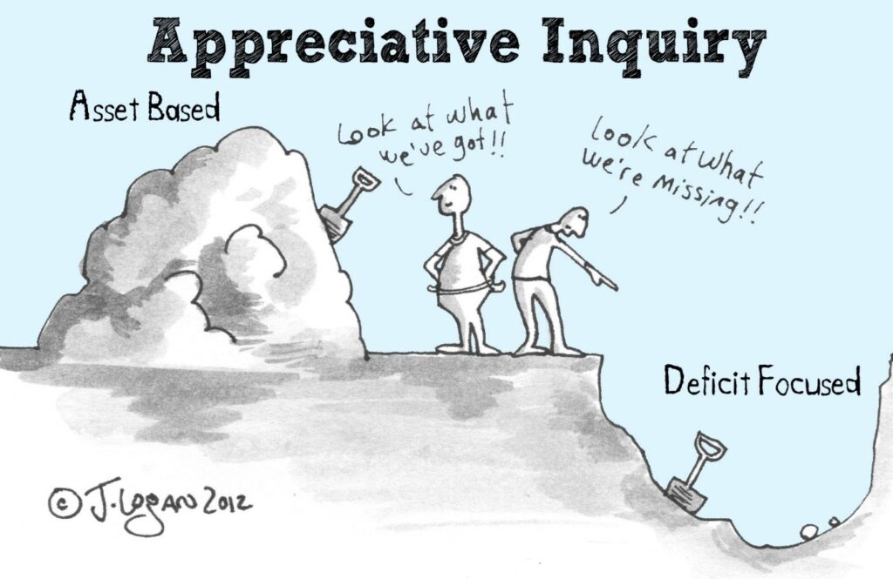

CHELTENHAM SUMMER INSTITUTE
OUTLINE PROGRAMME
“THERE REALLY ARE OTHER WAYS!”

DAY ONE: SOME ALTERNATIVE APPROACHES
Starting with a deep-dive into our shared purposes, values and principles, we will explore - via a variety of presentations, workshops and seminars led by the organisers and other invited thinkers, practitioners and leaders who are ‘delivering’ in other ways against the grain of their local system conditions – the alternatives and opportunities arising from a systemic commitment to strengths-based practice, localism, and a societal rather than commoditised underlying philosophy.
The conversations will continue into the evening with a visit to Dunkerton’s Cider Park for dinner.

DAY TWO: ALTERNATIVES IN DEPTH
Delegates will have the opportunity to participate in 2 half-day Workshops with:

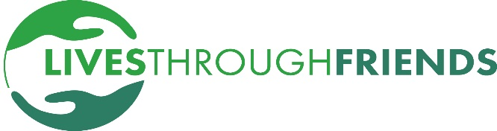
We will kick-off by investigating LivesthroughFriends’ ever-evolving Policy and Practice Framework; considering the nature of ‘care’, and the impacts and implications of reciprocal relationships, belonging, and contributing citizenship; and the potential inherent in strong citizens, families and communities.
LivesthroughFriends’ starting point – and, it seems, central to why so many of the people we assist go on to live ‘good lives’ – is based upon finding out what a person’s best possible life might be and setting out on a journey in that direction. With the assistance of self-advocates, family members, and professional ‘collaborators’ we’ll share lessons learned from pursuing this approach against the grain of a needs-focused, marketized system.
The workshop will be essentially practical but inevitably heavily laced with political issues and philosophical challenges. Michael J Sandel has suggested that the market economy has translated into the “market society”; and asks, “Do we want a society where everything is up for sale? Or are there certain moral and civic goods that markets do not honour and money cannot buy?”
It’s a question LivesthroughFriends has been posing for a long time.

The financial challenges facing the sector are unprecedented. Given this, we cannot continue running our systems as we have previously. We have an opportunity to redesign our systems for the better.
In this workshop you will have the opportunity to spend time understanding the application of the Vanguard Method, which has successfully helped leaders redesign their systems leading to better outcomes, reduced demand, increased capacity and improved morale.
We will help you understand where to start, introduce you to the frameworks that sustain change, and demonstrate why challenging our existing assumptions about the design and management of the health and social care system can unlock dramatic improvements.

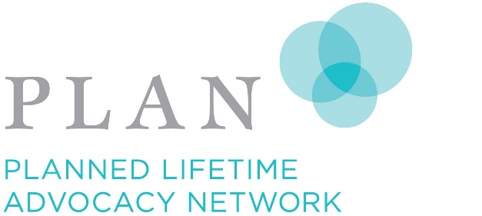
PLAN itself started as a small group of parents who came together in 1989 to face intractable issues of segregation, stigma and isolation for their children with disabilities, and their own fears and insecurity about the future of their sons and daughters. Out of this deep solidarity of shared struggle came several profound social innovations which would transform the lives of persons with disabilities. These innovations, in particular the personal support network, place caring relationships at the centre of a good life for the person with a disability (as they are for any of us). This innovation and the spirit of the movement behind them serve as a powerful evidence-based “model of success” for the national family movement that has taken hold in Canada and influenced family leadership in many parts of the world, where we would assert that well organized, unified and strong movements also encourage bold political decision making.
In this workshop we’ll be considering (inter-alia):
1) What does it mean to think and act like a movement?
2) What are our roles and responsibilities as families to support disability leadership?
3) How can we set about unifying an all-inclusive disability movement?

The Butterfly Garden
In 2002 six young autistic people walked into a plant nursery and ask the owner if he would teach them gardening. Two decades on it provides a myriad of opportunities for participation and contribution with its doors open to anyone without obligation. No-one pays and, until very recently when Chris started to plan his own retirement, no-ne got paid.
The very essence of the Butterfly Garden can be summed up as a resistance to institutionalisation and a celebration of self-realisation, interdependence, welcoming, and community. Chris Evans (Founder and site owner) and the charity’s Trustees (most of whom are volunteers, beneficiaries or both) are averse to the receipt of any funds with strings attached. There’s a constant flow of referrals from the local authority, NHS, and commissioned care providers but no contracts and funding ensue. Enquirers are simply reminded that the project has an ‘Open Door’ policy and that any citizen is welcome to come along to participate and contribute as they wish. More than 100 people choose to join in every day. The project describes itself as an educational, therapeutic and recreational scheme for people of all ages dealing with disablement of any kind. As Chris puts it, “It caters for those looking to escape the world, those looking to re-enter it and some, who are still just looking”.
What has the world to learn from The Butterfly Garden ‘journey’. You can immerse yourself and find out!

Day Two will also end with Dinner somewhere interesting and more opportunity for networking.

DAY THREE: MAKING SENSE OF THINGS – IMAGINING ALTERNATIVE SCENARIOS
We have conceived this ‘headspace retreat’ as, at least in part, a learning set and, hence, anticipate the need to design the final day around the emerging interests and interests of the delegates and the likelihood that we’ll be facilitating sessions during the day in the light of questions, issues and practicalities that delegates wish to address.
We’ll start the day with a Reprise and Review session and then organise accordingly, likely around 4 or 5 topics with 3 hour long sessions before lunch in order that delegates can immerse themselves in a number of ‘problem-solving and planning’ conversations.
We also believe that celebration should be an essential ‘take-away’ and we’ll be inviting delegates to contribute to an afternoon of uplifting and life affirming stories that hosts are excited to share.

